Graph

Table of Contents
3. Cycle Detection — Undirected & Directed Graphs 4
GFG supplements 4
4. Bipartite Graph & Graph Coloring 4
GFG supplements 4
Final unique set 4
GFG supplements 5
5. Topological Sort & DAG Problems 5
GFG supplements 5
Important progression 6
6. Unweighted Shortest Path — BFS 6
GFG supplements 6
8. Weighted Shortest Path — Dijkstra / Bellman-Ford / 0-1 BFS 6
GFG supplements 6
Algorithm selection you should know 7
9. Disjoint Set Union — Union-Find & Connectivity 7
GFG supplements 7
Must-master implementation 7
10. Minimum Spanning Tree — Prim & Kruskal 7
GFG supplements 8
Important progression 8
11. Strongly Connected Components, Bridges & Articulation Points 8
GFG supplements 8
Core concepts 8
12. Advanced Graph Applications 9
GFG supplements 9
Theory: Basics of Graph 9
1.1 What is a Graph? 9
1.2 Basic Terminology 10
1.3 Basic Types of Graphs 10
1.4 Graph representation 12
Theory: Graph Traversal 12
2.1. Depth-First Search (DFS) 12
2.2. Breadth-First Search (BFS) 13
2.3. Bipartite Graph 14
2.4. Topological Sort (make it separate section) 15
3.1. Dijkstra Algorithm for shortest path 17
Graph Fundamentals - Representation, Traversal 29
1. Create adjacency list 29
2. Depth First Search 29
3. Breadth First Search 29
4. Find if path exists in graph (1971) 29
5. All paths from source to target (797) 29
6. Number of Provinces (547) 29
7. Clone Graph (133) 29
8. Count the number of complete components (2685) 29
Union Find + Grid as Graph 30
1. Number of Islands (200) 30
2. Max Area of island (695) 30
3. Number of enclaves (1020) 30
4. Rotten Oranges (994) 30
5. Detect cycle in undirected graph(cycle detection can be other topic) 30
6. Detect cycle in directed graph 30
8. Bipartite Graph 30
Topological Sort 31
1. Topological Sort 31
2. Course Schedule 31
3. Loud and Rich 31
4. Find Eventual Safe Stated. 31
5. Alien Dictionary 31
Shortest Path 32
1. Dijkstra Algorithm 32
2. Shortest Path in Weighted Undirected Graph 32
3. Shortest Distance in a Binary Matrix 32
4. Path With Minimum Effort 32
5. Cheapest Flights Within K Stops 32
6. Distance from the source 32
7. Find City With Smallest Number of neighbors at threshold distance 32
Solutions: Graph Fundamentals - Representation, Traversal 33
Solutions: Union Find + Grid as Graph 39
Solutions: Topological Sort 46
Solutions: Shortest Path 49

6. Unweighted Shortest Path — BFS
BFS is the standard shortest-path approach when every edge has equal/unweighted cost. The first time BFS reaches a vertex, it has found a shortest path in terms of number of edges.
- 1091 — Shortest Path in Binary Matrix — 🟡 Medium — LeetCode
- 752 — Open the Lock — 🟡 Medium — LeetCode
- 433 — Minimum Genetic Mutation — 🟡 Medium — LeetCode
- 127 — Word Ladder — 🔴 Hard — LeetCode (IMP) – solution at end
- 1293 — Shortest Path in a Grid with Obstacles Elimination — 🔴 Hard — LeetCode

GFG supplements
- Shortest Path in an Unweighted Graph — 🟢 Easy — GFG (IMP)
- Shortest Path in Undirected Graph — 🟢 Easy — GFG
- Steps by Knight — 🟡 Medium — GFG
- Minimum Steps to Reach Target by a Knight — 🟡 Medium — GFG

8. Weighted Shortest Path — Dijkstra / Bellman-Ford / 0-1 BFS
This section covers the major weighted shortest-path families. Dijkstra is appropriate for graphs with non-negative edge weights; Bellman-Ford is useful when negative edges are allowed and also supports negative-cycle detection. GFG's current Graph interview material explicitly includes Dijkstra, Bellman-Ford, Floyd-Warshall, and 0-1 BFS among important graph algorithms.
- 743 — Network Delay Time — 🟡 Medium — LeetCode
- 1514 — Path with Maximum Probability — 🟡 Medium — LeetCode
- 787 — Cheapest Flights Within K Stops — 🟡 Medium — LeetCode
- 1631 — Path With Minimum Effort — 🟡 Medium — LeetCode
- 1368 — Minimum Cost to Make at Least One Valid Path in a Grid — 🟡 Medium — LeetCode
- 778 — Swim in Rising Water — 🔴 Hard — LeetCode

GFG supplements
- Dijkstra's Algorithm — 🟡 Medium — GFG
- Implementing Dijkstra Algorithm — 🟡 Medium — GFG
- Bellman-Ford Algorithm — 🟡 Medium — GFG
- Floyd-Warshall Algorithm — 🟡 Medium — GFG
- 0-1 BFS — 🟡 Medium — GFG
- Shortest Path in a Weighted Graph — 🟡 Medium — GFG

Algorithm selection you should know
Unweighted → BFS
0/1 edge weights → 0-1 BFS
Non-negative weighted graph → Dijkstra
Negative edges → Bellman-Ford
All-pairs shortest path → Floyd-Warshall

9. Disjoint Set Union — Union-Find & Connectivity
DSU is one of the most important Graph techniques for dynamically maintaining connected components. It is especially useful for connectivity and cycle detection and is also a key part of Kruskal's MST algorithm. GFG's current interview list explicitly includes Union-Find and Kruskal among its core Graph problems.
- 684 — Redundant Connection — 🟡 Medium — LeetCode
- 1319 — Number of Operations to Make Network Connected — 🟡 Medium — LeetCode
- 947 — Most Stones Removed with Same Row or Column — 🟡 Medium — LeetCode
- 990 — Satisfiability of Equality Equations — 🟡 Medium — LeetCode
- 721 — Accounts Merge — 🟡 Medium — LeetCode
- 1202 — Smallest String With Swaps — 🟡 Medium — LeetCode
- 1584 — Min Cost to Connect All Points — 🟡 Medium — LeetCode
- 1579 — Remove Max Number of Edges to Keep Graph Fully Traversable — 🔴 Hard — LeetCode

GFG supplements
- Disjoint Set Union / Union-Find — 🟢 Easy — GFG
- Detect Cycle in an Undirected Graph using DSU — 🟡 Medium — GFG
- Kruskal's Minimum Spanning Tree — 🟡 Medium — GFG
- Number of Connected Components — 🟢 Easy — GFG

Must-master implementation
- find()
- Path compression
- union()
- Union by rank
- Union by size
- Counting connected components

10. Minimum Spanning Tree — Prim & Kruskal
An MST connects all vertices with minimum total edge weight without cycles. The two fundamental interview algorithms are Kruskal and Prim.
- 1584 — Min Cost to Connect All Points — 🟡 Medium — LeetCode
- 1135 — Connecting Cities With Minimum Cost — 🟡 Medium — LeetCode
- 1489 — Find Critical and Pseudo-Critical Edges in Minimum Spanning Tree — 🔴 Hard — LeetCode
- 1168 — Optimize Water Distribution in a Village — 🔴 Hard — LeetCode

GFG supplements
- Minimum Spanning Tree — 🟢 Easy — GFG
- Prim's Minimum Spanning Tree — 🟡 Medium — GFG
- Kruskal's Minimum Spanning Tree — 🟡 Medium — GFG
- Minimum Cost to Connect All Points — 🟡 Medium — GFG
- Minimum Cost to Connect All Houses — 🟡 Medium — GFG

Important progression
Kruskal → DSU → Prim → Heap-based Prim → Critical/Pseudo-Critical MST edges

11. Strongly Connected Components, Bridges & Articulation Points
These are the advanced connectivity patterns. They are particularly important for senior-level Graph interviews.
A bridge is an edge whose removal increases the number of connected components; articulation points are vertices whose removal can disconnect the graph.
- 1192 — Critical Connections in a Network — 🔴 Hard — LeetCode

GFG supplements
- Bridges in a Graph — 🔴 Hard — GFG
- Articulation Point in a Graph — 🔴 Hard — GFG
- Strongly Connected Components — Kosaraju's Algorithm — 🟡 Medium — GFG
- Strongly Connected Components — Tarjan's Algorithm — 🔴 Hard — GFG
- Mother Vertex — 🟡 Medium — GFG
- Transitive Closure of a Graph — 🟡 Medium — GFG

Core concepts
- Discovery time
- Low-link value
- DFS tree
- Back edges
- Bridge condition
- Articulation-point condition
- SCC
- Kosaraju
- Tarjan
GFG's current Graph interview list explicitly includes bridges, SCCs using Kosaraju/Tarjan, articulation points, and Mother Vertex among its advanced interview questions.

12. Advanced Graph Applications
These are graph problems where the underlying graph model is slightly less obvious. They are excellent interview questions after the fundamental patterns are comfortable.
- 399 — Evaluate Division — 🟡 Medium — LeetCode
- 1462 — Course Schedule IV — 🟡 Medium — LeetCode
- 310 — Minimum Height Trees — 🟡 Medium — LeetCode
- 2115 — Find All Possible Recipes from Given Supplies — 🟡 Medium — LeetCode
- 332 — Reconstruct Itinerary — 🔴 Hard — LeetCode
- 2097 — Valid Arrangement of Pairs — 🔴 Hard — LeetCode

GFG supplements
- Mother Vertex — 🟡 Medium — GFG
- Circle of Strings — 🟡 Medium — GFG
- Possible Paths Between Two Vertices — 🟡 Medium — GFG
- Maximum Bipartite Matching — 🔴 Hard — GFG
- Euler Circuit in an Undirected Graph — 🟡 Medium — GFG
- Eulerian Path in Directed Graph — 🟡 Medium — GFG

All Theory in one H1 heading
H2 heading for sections(included in index)
1. Graph Fundamentals > sub sections(H3) not included in sections
2. Graph Traversals
3. Bipartitie Graph
4. Topological Sort
….

Theory: Basics of Graph

1.1 What is a Graph?
Definition: A graph G= (V, E) consists of a set of vertices V and a set of edges E.
PUT better image 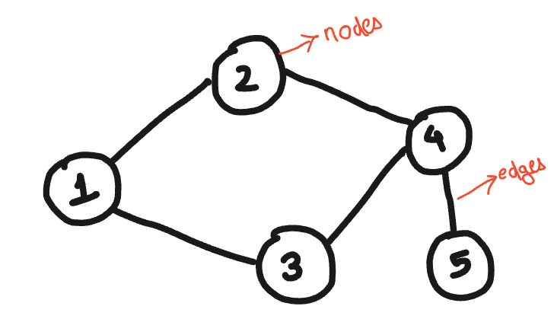

1.2 Basic Terminology
- Vertex (Node): An individual entity in a graph.
- Edge (Link): Connection between two vertices.
- Degree: Number of edges connected to a vertex.
  - In-degree and Out-degree in directed graphs.
- Path: Sequence of edges connecting vertices.
- Cycle: Path that starts and ends at the same vertex.
- Component: A maximally connected subgraph.

1.3 Basic Types of Graphs
- Undirected Graph:
A graph where edges have no direction. The edge (u, v) is identical to (v, u).
- Directed Graph (Digraph):
A graph where edges have a direction. The edge (u, v) is not the same as (v, u).
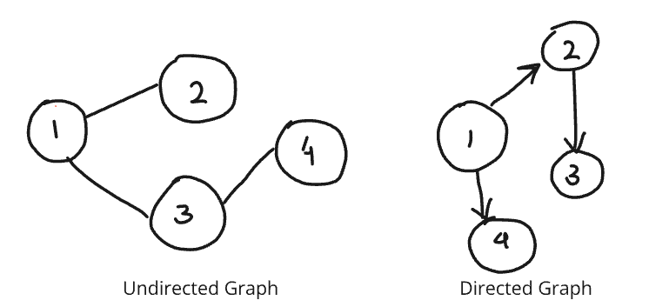
- Weighted Graph:
A graph where edges have weights representing costs, distances, or capacities.
- Unweighted Graph:
A graph where edges do not have weights.
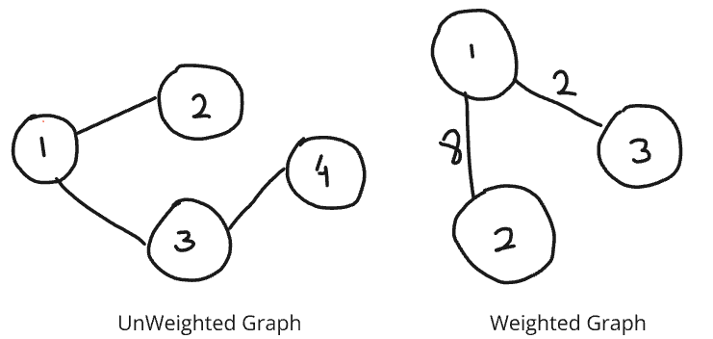

- Connected Graph:
A graph in which there is a path between every pair of vertices.
- Disconnected Graph:
A graph that is not connected; it consists of multiple connected components.

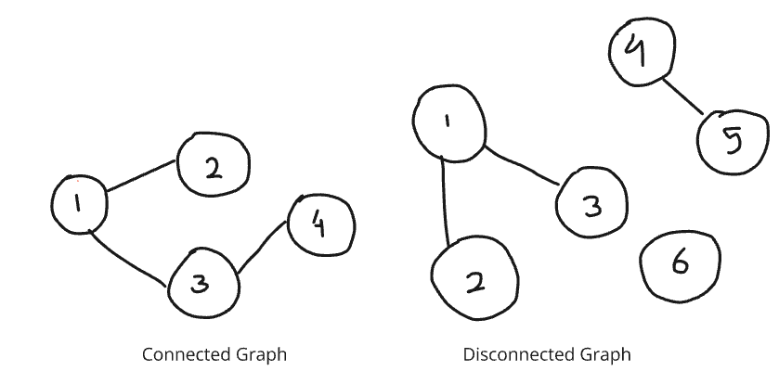

- Complete Graph (Kn):
A graph where there is an edge between every pair of vertices.

- Cycle Graph (Cn):
A graph that forms a single cycle where each vertex has exactly two neighbours.

- Tree:
A connected acyclic graph. Trees have a hierarchical structure with a root node.

- Forest:
A collection of disjoint trees.

- Bipartite Graph:
A graph whose vertices can be divided into two disjoint sets U and V such that every edge connects a vertex in U to a vertex in V.

- Directed Acyclic Graph (DAG):
A directed graph with no cycles. DAGs are used in various applications like scheduling, representing hierarchies, and data flow diagrams.

1.4 Graph representation

# Adjacency List Representation
graph = {
'A': ['B', 'C'],
'B': ['A', 'D', 'E'],
'C': ['A', 'F'],
'D': ['B'],
'E': ['B', 'F'],
'F': ['C', 'E']
}

# Adjacency Matrix Representation
import numpy as np
adj_matrix = np.array([
[0, 1, 1, 0, 0, 0],
[1, 0, 0, 1, 1, 0],
[1, 0, 0, 0, 0, 1],
[0, 1, 0, 0, 0, 0],
[0, 1, 0, 0, 0, 1],
[0, 0, 1, 0, 1, 0]
])

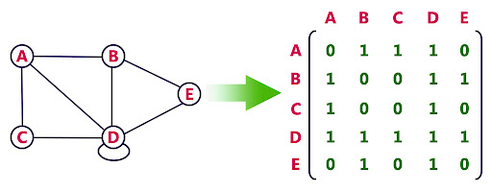
Adjacency matrix

Theory: Graph Traversal

2.1. Depth-First Search (DFS)
- Theory: Explore as far as possible along each branch before backtracking.
- Algorithm:
  - Start at the root (or any arbitrary node).
  - Mark the node as visited.
  - Recursively visit all unvisited adjacent nodes.

def dfs(graph, start, visited=None):
if visited is None:
visited = set()
visited.add(start)
print(start)
for neighbour in graph[start]:
if neighbour not in visited:
dfs(graph, neighbour, visited)
return visited

# Example Usage
graph = {
'A': ['B', 'C'],
'B': ['A', 'D', 'E'],
'C': ['A', 'F'],
'D': ['B'],
'E': ['B', 'F'],
'F': ['C', 'E']
}
dfs(graph, 'A')

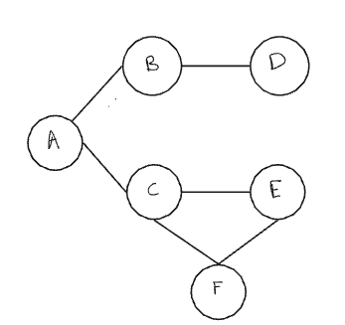

OUTPUT: A B D E F C

2.2. Breadth-First Search (BFS)
- Theory: Explore all neighbors at the present depth prior to moving on to nodes at the next depth level.
- Algorithm:
  - Start at the root (or any arbitrary node).
  - Mark the node as visited.
  - Add the node to the queue.
  - While the queue is not empty:
    - Dequeue a node.
    - Visit all unvisited adjacent nodes and add them to the queue.

from collections import deque

def bfs(graph, start):
visited = set()
queue = deque([start])
visited.add(start)
while queue:
vertex = queue.popleft()
print(vertex)
for neighbor in graph[vertex]:
if neighbor not in visited:
visited.add(neighbor) # Add node here itself in visited
queue.append(neighbor)
graph = {
'A': ['B', 'C'],
'B': ['A', 'D', 'E'],
'C': ['A', 'F'],
'D': ['B'],
'E': ['B', 'F'],
'F': ['C', 'E']
}

# Example Usage
bfs(graph, 'A')

#Output: A B C D E F

Time complexity:-

For both DFS and BFS:
- Each node is visited exactly once.
- Each edge is explored at most twice.

Thus, the time complexity is: O(V + E)

2.3. Bipartite Graph

A bipartite graph is a type of graph in which the set of vertices can be divided into two disjoint sets UUU and VVV such that every edge connects a vertex in UUU to a vertex in VVV. In other words, no two vertices within the same set are adjacent.
Conditions:
- Two Colorability: A graph is bipartite if and only if it is possible to color the vertices using two colors such that no two adjacent vertices have the same color.
- No Odd-Length Cycles: A graph is bipartite if and only if it does not contain any odd-length cycles.(means all graph without cycle or graph with even cycle length are bipartite)
Logic to check if a Graph is Bipartite:
To check if a graph is bipartite, we can use a breadth-first search (BFS) or depth-first search (DFS) approach to attempt to color the graph using two colors. If we can successfully color the graph such that no two adjacent vertices share the same color, then the graph is bipartite. If we encounter a situation where an adjacent vertex needs to be the same color, the graph is not bipartite.
from collections import deque

def is_bipartite(graph):
color = {}

for node in graph:
if node not in color:
queue = deque([node])
color[node] = 0

while queue:
current = queue.popleft()
for neighbor in graph[current]:
if neighbor not in color:
color[neighbor] = 1 - color[current]
queue.append(neighbor)
elif color[neighbor] == color[current]:
return False
return True
# Example Usage
graph = {
'A': ['B', 'C'],
'B': ['A', 'D'],
'C': ['A', 'D'],
'D': ['B', 'C']
}
print(is_bipartite(graph)) # Output: True
graph = {
'A': ['B', 'C'],
'B': ['A', 'C'],
'C': ['A', 'B']
}
print(is_bipartite(graph)) # Output: False

2.4. Topological Sort (make it separate section)

Topological Sort is a linear ordering of vertices in a Directed Acyclic Graph (DAG) such that for every directed edge u → v, vertex u comes before v in the ordering.

Property | Description
Graph Type | Only applicable to Directed Acyclic Graphs (DAGs)
Edge Constraint | For edge u → v, u must appear before v in the sort
Multiple Orders Possible | A DAG can have multiple valid topological orderings
Not Applicable for Cycles | If the graph has a cycle, topological sort is not possible
Vertices in Linear Order | The result is a list of nodes arranged in a dependency-resolved order

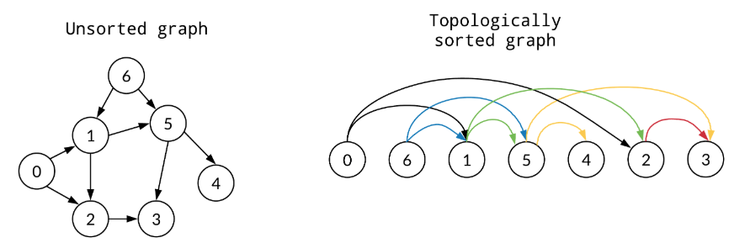

Use Cases of Topological Sort

Use Case | Description
✅ Task Scheduling | If some tasks must be done before others (e.g., course prerequisites)
✅ Build Systems | Compiling source files in dependency order
✅ Package Managers | Installing packages respecting dependency order
✅ Project Management | Resolving task dependencies in workflows (e.g., Gantt charts)
✅ Circuit Design | Signal propagation order

Approaches to Topological Sort

- DFS-Based (Depth-First Search)
  - Push node to result stack after processing all its neighbors.
  - Final result is reverse of the postorder traversal.
- BFS-Based (Kahn’s Algorithm)
  - Uses in-degree array to find nodes with no incoming edges.
  - Uses queue to process nodes in dependency-free order.

Topological sort using DFS

# Graph as adjacency list
def topological_sort_dfs(graph):
visited = set()
result = []

def dfs(node):
visited.add(node)
for neighbor in graph.get(node, []):
if neighbor not in visited:
dfs(neighbor)
result.append(node) # Append after visiting all neighbors

for node in graph:
if node not in visited:
dfs(node)

return result[::-1] # Reverse the result

Topological sort using BFS(Kahn’s Algorithm)

from collections import deque, defaultdict

def topological_sort_bfs(graph):
in_degree = defaultdict(int)
result = []

# Initialize in-degree of all nodes
for node in graph:
for neighbor in graph[node]:
in_degree[neighbor] += 1

# Queue for nodes with in-degree 0
queue = deque([node for node in graph if in_degree[node] == 0])

while queue:
node = queue.popleft()
result.append(node)
for neighbor in graph[node]:
in_degree[neighbor] -= 1
if in_degree[neighbor] == 0:
queue.append(neighbor)

# If all nodes are processed, return result
if len(result) == len(graph):
return result
else:
raise Exception("Graph has a cycle. Topological Sort not possible.")

Theory: Shortest Path

3.1. Dijkstra Algorithm for shortest path

Dijkstra's Algorithm finds the shortest path from a source node to all other nodes in a weighted graph with non-negative weights.
Think of it like finding the fastest route on a map where roads have different travel times.

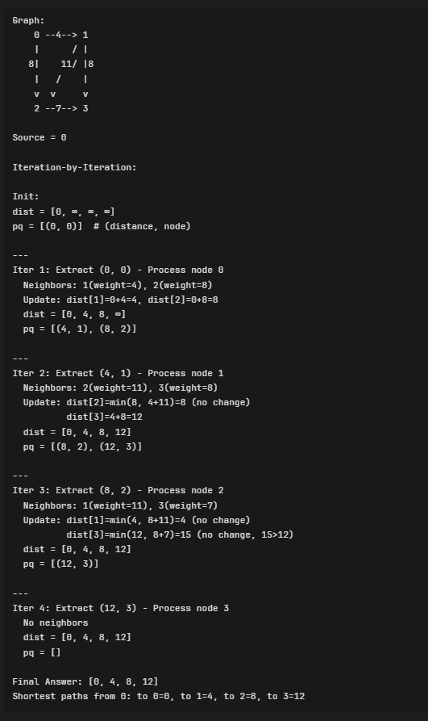
Intuition - Greedy Approach: Always pick the closest unvisited node and explore its neighbors.
Key Insight:
- Once we finalize a node's distance, we've found its shortest path
- We process nodes in order of increasing distance from source
- If we reach a node via the shortest known path, and all weights are positive, no future path can be shorter

import heapq

def dijkstra(graph, start):
# Initialize distances with infinity for all vertices except the start
distances = {vertex: float('infinity') for vertex in graph}
distances[start] = 0

# Initialize priority queue with the start vertex and distance 0
priority_queue = [(0, start)]

while priority_queue:
# Pop the vertex with the smallest distance from the priority queue
current_distance, current_vertex = heapq.heappop(priority_queue)

# If the popped distance is greater than the current known distance, skip it
if current_distance > distances[current_vertex]:
continue

# Check and update distances for all neighboring vertices
for neighbor, weight in graph[current_vertex].items():
distance = current_distance + weight
if distance < distances[neighbor]:
distances[neighbor] = distance
heapq.heappush(priority_queue, (distance, neighbor))

return distances

# Example Usage
graph = {
'A': {'B': 1, 'C': 4},
'B': {'A': 1, 'D': 2, 'E': 5},
'C': {'A': 4, 'F': 3},
'D': {'B': 2},
'E': {'B': 5, 'F': 1},
'F': {'C': 3, 'E': 1}
}

print(dijkstra(graph, 'A'))

It does not work with negative edge weight. As gets stuck in infinite loop.

Explanation:
- Initialization: Distances to all vertices are set to infinity except the start vertex, which is set to 0.
- Priority Queue: A priority queue (min-heap) is initialized with the start vertex.
- Processing: The vertex with the smallest known distance is extracted from the priority queue.
- Distance Update: For each neighbour of the current vertex, the distance is updated if a shorter path is found. The neighbour and the updated distance are then pushed onto the priority queue.
- Check and Skip: If the current distance of the extracted vertex is greater than the known shortest distance, it is skipped.

Time & Space Complexity
Priority Queue Method:
- Time: O((V + E) log V)
  - V nodes, each pushed/popped: O(V log V)
  - E edges, each relaxation: O(E log V)
- Space: O(V) for dist array + O(V) for heap

When NOT to Use Dijkstra
❌ Negative edge weights → Use Bellman-Ford instead
❌ Unweighted graphs → Use BFS (simpler & faster)
❌ All-pairs shortest paths → Use Floyd-Warshall
✅ Perfect for: GPS navigation, network routing, shortest path in weighted graphs

3.2. Bellman Ford Algorithm for shortest path

Bellman-Ford finds the shortest path from a source to all other nodes in a graph that can have negative edge weights. It also detects negative cycles.
Dijkstra vs Bellman-Ford:
- Dijkstra: Faster O((V+E)logV) but fails with negative weights ❌
- Bellman-Ford: Slower O(V×E) but handles negative weights ✅

Intuition
Key Idea: Repeatedly relax all edges to gradually find shorter paths.
Relaxation means: "Can I reach node B cheaper by going through node A?"
If dist[A] + weight(A→B) < dist[B]:
dist[B] = dist[A] + weight(A→B) # Found a better path!

Dry Run
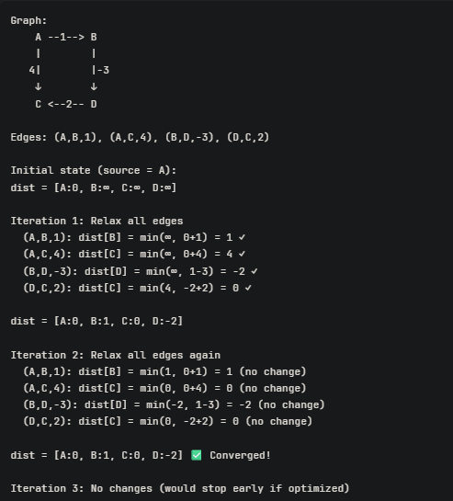
Negative Cycle Detection
Key Insight: If we can still improve distances after N-1 iterations, there's a negative cycle!
Why?
- After N-1 iterations, all shortest paths should be found
- If Nth iteration still updates → cycle exists that keeps reducing cost
- This cycle must be negative (otherwise wouldn't keep improving)

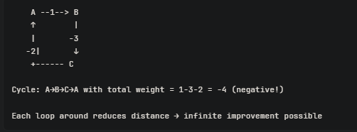

Approach:
1. Initialize dist[source] = 0, all others = ∞
2. Repeat (N-1) times:
For each edge (u, v, weight):
if dist[u] + weight < dist[v]:
dist[v] = dist[u] + weight (relax)
3. Check for negative cycle:
For each edge (u, v, weight):
if dist[u] + weight < dist[v]:
return "Negative cycle detected!"
4. Return dist array
Time Complexity: O(v x E)
Space Complexity: O(V)

✅ Use when:
- Graph has negative edge weights
- Need to detect negative cycles
- Graph is sparse and not too large
❌ Don't use when:
- All weights are non-negative → Use Dijkstra (faster)
- Need all-pairs shortest paths → Use Floyd-Warshall
- Graph is very large → Too slow O(V×E)

def bellman_ford(V, edges, src):
"""
V: number of vertices
edges: list of (u, v, weight)
src: source node
Returns: (distances, has_negative_cycle)
"""
# Step 1: Initialize distances
dist = [float('inf')] * V
dist[src] = 0

# Step 2: Relax edges (V-1) times
for i in range(V - 1):
# Track if any update happened (optimization)
updated = False

for u, v, weight in edges:
if dist[u] != float('inf') and dist[u] + weight < dist[v]:
dist[v] = dist[u] + weight
updated = True

# Early termination if no updates
if not updated:
break

# Step 3: Check for negative cycle
for u, v, weight in edges:
if dist[u] != float('inf') and dist[u] + weight < dist[v]:
return None, True # Negative cycle detected!

return dist, False

# Example Usage
if __name__ == "__main__":
V = 5
edges = [
(0, 1, 6),
(0, 2, 7),
(1, 3, 5),
(2, 3, 8),
(2, 4, -4),
(4, 3, 9)
]

dist, has_neg_cycle = bellman_ford(V, edges, 0)

if has_neg_cycle:
print("Negative cycle detected!")
else:
print("Shortest distances from node 0:", dist)
# Output: [0, 6, 7, 11, 3]

3.3. Floyd Warshall Algorithm for shortest path

Floyd-Warshall finds the shortest paths between ALL pairs of nodes in a weighted graph. It can handle negative edge weights and detect negative cycles.
Comparison:
- Dijkstra: Single source → All nodes, O((V+E)logV), no negative weights
- Bellman-Ford: Single source → All nodes, O(V×E), handles negative weights
- Floyd-Warshall: All pairs, O(V³), handles negative weights ✅

Intuition
Dynamic Programming Approach: Build shortest paths incrementally by considering intermediate nodes.
Key Question: "Can I go from i to j faster by going through node k?"
For every pair (i, j):
Try all possible intermediate nodes k
If path i→k→j is shorter than direct i→j:
Update shortest path i→j

Dry Run
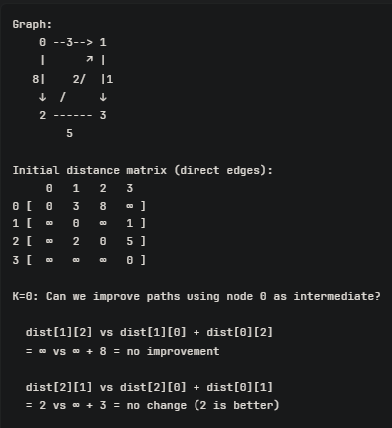

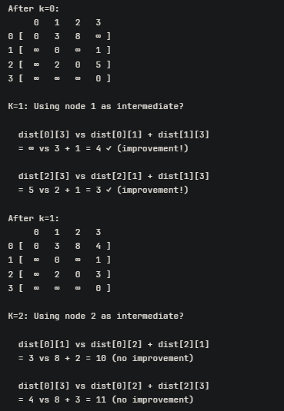
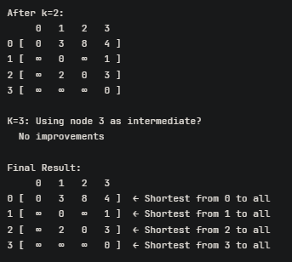

Approach
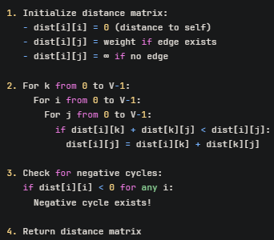

def floyd_warshall(V, edges):
"""
V: number of vertices
edges: list of (u, v, weight)
Returns: distance matrix or None if negative cycle
"""
# Step 1: Initialize distance matrix
INF = float('inf')
dist = [[INF] * V for _ in range(V)]

# Distance to self is 0
for i in range(V):
dist[i][i] = 0

# Fill in edge weights
for u, v, w in edges:
dist[u][v] = w

# Step 2: Floyd-Warshall algorithm
for k in range(V):
for i in range(V):
for j in range(V):
if dist[i][k] != INF and dist[k][j] != INF:
dist[i][j] = min(dist[i][j], dist[i][k] + dist[k][j])

# Step 3: Check for negative cycles
for i in range(V):
if dist[i][i] < 0:
return None # Negative cycle detected

return dist

Negative Cycle Detection
Key Insight: If the shortest path from a node to itself becomes negative, there's a negative cycle!

# After Floyd-Warshall completes
for i in range(V):
if dist[i][i] < 0:
return "Negative cycle detected!"

Graph Fundamentals - Representation, Traversal
This section builds the basic graph mental model: adjacency list/matrix, BFS/DFS, visited state, connected components, and simple reachability. BFS and DFS are the fundamental graph traversal algorithms, both taking O(V + E) with an adjacency-list representation.

1. Create adjacency list
Link: https://www.geeksforgeeks.org/problems/print-adjacency-list-1587115620/1

2. Depth First Search
Link: https://www.geeksforgeeks.org/problems/depth-first-traversal-for-a-graph/1
- Keys and Rooms (841)

3. Breadth First Search
Link: https://www.geeksforgeeks.org/problems/bfs-traversal-of-graph/1

4. Find if path exists in graph (1971)
Link: https://leetcode.com/problems/find-if-path-exists-in-graph/
- Find the Town Judge (997)

5. All paths from source to target (797)
Link: https://leetcode.com/problems/all-paths-from-source-to-target/

6. Number of Provinces (547)
Link: https://leetcode.com/problems/number-of-provinces/

7. Clone Graph (133)
Link: https://leetcode.com/problems/clone-graph/description/

8. Count the number of complete components (2685)
Link: https://leetcode.com/problems/count-the-number-of-complete-components/description/

9. Detect cycle in undirected graph
Link: https://www.geeksforgeeks.org/problems/detect-cycle-in-an-undirected-graph/1

Grid as Graph
A matrix can be treated as an implicit graph: each cell is a vertex and neighbouring cells are edges. The key skills are marking visited nodes, counting components, and exploring regions with BFS/DFS.

1. Number of Islands (200)
Link: https://leetcode.com/problems/number-of-islands/
- Flood Fill (733)

2. Max Area of island (695)
Link: https://leetcode.com/problems/max-area-of-island/description/
- Island Perimeter (463)

3. Number of enclaves (1020)
Link: https://leetcode.com/problems/number-of-enclaves/
- Surrounded Regions (130)
- Count Sub Islands (1905)

4. Rotten Oranges (994)
Link: https://leetcode.com/problems/rotting-oranges/description/
- 01 Matrix (542)

Bipartite Graph
The central idea is to assign one of two colors to every vertex such that adjacent vertices receive different colors.

- 785 — Is Graph Bipartite? — 🟡 Medium — LeetCode
- 886 — Possible Bipartition — 🟡 Medium — LeetCode
- 1042 — Flower Planting With No Adjacent — 🟢 Easy — LeetCode

GFG supplements
- Bipartite Graph — 🟢 Easy — GFG
- Check if Graph is Bipartite using BFS — 🟢 Easy — GFG
- Check if Graph is Bipartite using DFS — 🟡 Medium — GFG
- M-Coloring Problem — 🔴 Hard — GFG

Topological Sort
Topological sorting applies to directed acyclic graphs and produces an ordering where every directed edge u → v places u before v. It can be implemented through DFS or Kahn's BFS-based algorithm.

8. Bipartite Graph
Link: https://leetcode.com/problems/is-graph-bipartite/
- 207 — Course Schedule — 🟡 Medium — LeetCode
- 210 — Course Schedule II — 🟡 Medium — LeetCode
- 802 — Find Eventual Safe States — 🟡 Medium — LeetCode (IMP)
- 310 — Minimum Height Trees — 🟡 Medium — LeetCode
- 1462 — Course Schedule IV — 🟡 Medium — LeetCode
- 2115 — Find All Possible Recipes from Given Supplies — 🟡 Medium — LeetCode
- 269 — Alien Dictionary — 🔴 Hard — LeetCode

GFG supplements
- Topological Sort — 🟢 Easy — GFG
- Kahn's Algorithm for Topological Sorting — 🟢 Easy — GFG
- Prerequisite Tasks — 🟡 Medium — GFG
- All Topological Sorts of a Directed Acyclic Graph — 🟡 Medium — GFG
- Alien Dictionary — 🔴 Hard — GFG

1. Topological Sort
Link: https://www.geeksforgeeks.org/problems/topological-sort/1

2. Course Schedule
Link: https://leetcode.com/problems/course-schedule/description/

3. Loud and Rich
Link: https://leetcode.com/problems/loud-and-rich/

4. Find Eventual Safe Stated.
Link:
Go through video and do by both dfs and bfs : https://www.youtube.com/watch?v=2gtg3VsDGyc&list=PLgUwDviBIf0oE3gA41TKO2H5bHpPd7fzn&index=25

5. Alien Dictionary
Link: find equivalent question in leetcode.

2. Detect cycle in directed graph
Link: https://www.geeksforgeeks.org/problems/detect-cycle-in-a-directed-graph/1

- 934 — Shortest Bridge — 🟡 Medium — LeetCode
- 815 — Bus Routes — 🔴 Hard — LeetCode
- 864 — Shortest Path to Get All Keys — 🔴 Hard — LeetCode GFG supplements
- Distance of Nearest Cell Having 1 — 🟡 Medium — GFG
- Steps by Knight — 🟡 Medium — GFG
- Minimum Time to Reach Destination Without Drowning — 🟡 Medium — GFG

Shortest Path

1. Dijkstra Algorithm
Link: https://www.geeksforgeeks.org/problems/implementing-dijkstra-set-1-adjacency-matrix/1

2. Shortest Path in Weighted Undirected Graph
Link: https://www.geeksforgeeks.org/problems/shortest-path-in-weighted-undirected-graph/1

3. Shortest Distance in a Binary Matrix
Link: https://www.geeksforgeeks.org/problems/shortest-path-in-a-binary-maze-1655453161/1

4. Path With Minimum Effort
Link: https://leetcode.com/problems/path-with-minimum-effort/

5. Cheapest Flights Within K Stops
Link: https://leetcode.com/problems/cheapest-flights-within-k-stops/

6. Distance from the source
Link: https://www.geeksforgeeks.org/problems/distance-from-the-source-bellman-ford-algorithm/1

7. Find City With Smallest Number of neighbors at threshold distance
Link: https://leetcode.com/problems/find-the-city-with-the-smallest-number-of-neighbors-at-a-threshold-distance/description/

Solutions: Graph Fundamentals - Representation, Traversal

- Create adjacency list

from typing import List
class Solution:
def printGraph(self, V: int, edges: List[List[int]]) -> List[List[int]]:
adj = [[] for _ in range(V)]

for edge in edges:
adj[edge[0]].append(edge[1])
adj[edge[1]].append(edge[0])

return adj

- Depth First Search

class Solution:
def dfs(self, adj):

def helper(node):
ans.append(node)
visited[node]=1
for neighbour in adj[node]:
if visited[neighbour] == 0:
helper(neighbour)

n = len(adj)
ans = []
visited = [0]*n
helper(0)

return ans

- Breadth First Search
from collections import deque
class Solution:
def bfs(self, adj):
ans = []
q = deque([0])
visited = set([0])

while q:
node = q.popleft()
ans.append(node)
for neighbour in adj[node]:
if neighbour not in visited:
visited.add(neighbour)
q.append(neighbour)

return ans

- Find if path exists

class Solution:
def validPath(self, n, edges: list[list[int]], source: int, destination: int) -> bool:

def helper(node):
visited[node]=True
for neighbour in adj[node]:
if not visited[neighbour]:
helper(neighbour)

adj = [[] for _ in range(n)]
for edge in edges:
adj[edge[0]].append(edge[1])
adj[edge[1]].append(edge[0])

visited=[False]*n
helper(source)
return visited[destination]

- All paths from source to target
This is Directed Acyclic graph, so no need to check for visited nodes as in DAG we won’t stuck in loop, and also we need all paths

class Solution:
def allPathsSourceTarget(self, graph: list[list[int]]) -> list[list[int]]:

def helper(node, path):
if node==destination:
ans.append(path+[destination])
for neighbour in graph[node]:
helper(neighbour, path+[node])

#for DAG, no need to maintain visited array
source, destination = 0, len(graph)-1
ans = []
helper(source, [])
return ans

- Number of Provinces
These is equivalent to counting number of components in disconnected graph. We run loop from 1 to n, and for non-visited node we call the dfs function. DFS mark all nodes connected to it as visited.
Thus whenever we calling dfs, it means that this node was not visited by any previous node, thus it is a new province (component).

class Solution:
def findCircleNum(self, isConnected: List[List[int]]) -> int:
#visit all connected node from given node
def dfs(node):
visited[node]=1
for neighbor in adj[node]:
if visited[neighbor]==0:
dfs(neighbor)

#adj matrix to adj list, considering 0 based indexing
n = len(isConnected)
adj = [[] for _ in range(n)]
for i in range(n):
for j in range(n):
if i!=j and isConnected[i][j]==1:
adj[i].append(j)

#number of provinces = number of components
visited = [0]*n
count=0
for i in range(n):
if visited[i]==0:
count+=1
dfs(i)

return count

- Clone Graph

from typing import Optional
class Solution:
def cloneGraph(self, node: Optional['Node']) -> Optional['Node']:

def dfs(curr):
if curr in copied:
return copied[curr]
clone = Node(curr.val, [])
copied[curr] = clone

for neighbor in curr.neighbors:
neighbor_clone = dfs(neighbor)
clone.neighbors.append(neighbor_clone)
return clone

if not node: return
copied = {}
return dfs(node)

8. Count the number of complete components
Using DFS: To get count of nodes that were traversed in given dfs, use a extra set. Now check every node in this set should be connect to all others nodes in given set, so the length of adjacency list for given node should be equal to len(set)-1.

class Solution:
def dfs(self,node,adj,visited,covered):
covered.add(node)
visited[node]=1
for neighbor in adj[node]:
if visited[neighbor]==0:
self.dfs(neighbor,adj,visited,covered)

def countCompleteComponents(self, n: int, edges: List[List[int]]) -> int:
#creating adj list from edges
adj = [[] for _ in range(n)]
for edge in edges:
adj[edge[0]].append(edge[1])
adj[edge[1]].append(edge[0])

#if on single dfs, n nodes were covered,
#in adj list all the n nodes should have n-1 connections
conComponents = 0
visited = [0]*n
for i in range(n):
if visited[i]==0:
covered = set() #store nodes covered in dfs
self.dfs(i,adj, visited,covered)

cov = len(covered)
isConn = True
for node in covered:
if len(adj[node])!=cov-1: #checks for each node
isConn = False
if isConn:
conComponents +=1
return conComponents

Using BFS: Let say number of nodes in component is n, then in bfs each node of component is present in adj list of n-1 nodes. So we will check at end if number of nodes which visited n-1 times in given bfs equals count of total nodes in component, if yes this component satisfy the condition and get included in final ans.
from collections import deque
class Solution:
def countCompleteComponents(self, n: int, edges: List[List[int]]) -> int:
#convert to adj list
adj = [[] for _ in range(n)]
for edge in edges:
adj[edge[0]].append(edge[1])
adj[edge[1]].append(edge[0])

visited = [0]*n
num_of_comp = 0

#finding number of disconnected components by bfs
for i in range(n):

if visited[i]==0: #means one new component
node_count=0 #check how many nodes are in component
queue = deque([i])
vis_count=[0]*n #check how many times each node in component is called
visited[i]=1

while(queue):
node = queue.popleft()
node_count+=1
for neighbour in adj[node]:
vis_count[neighbour]+=1
if visited[neighbour]==0:
queue.append(neighbour)
visited[neighbour]=1

#check if component is complete
#For complete component, all nodes are visited n-1 times
count=0
for i in vis_count:
if i==node_count-1:
count+=1

if count==node_count or node_count==1:
num_of_comp+=1

return num_of_comp

9. Detect cycle in undirected graph
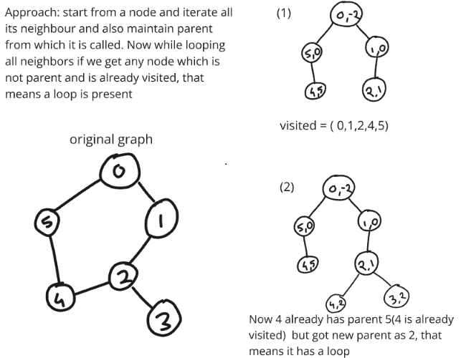
Note: Here Graph can have unconnected components
USING DFS

class Solution:

def dfs(self,node,parent,adj,visited):
visited[node]=True
for neighbor in adj[node]:
if visited[neighbor]:
if neighbor!=parent:
return True
elif self.dfs(neighbor, node,adj,visited):
return True
return False

def isCycle(self, V, edges):
adj = [[] for _ in range(V)]
for edge in edges:
adj[edge[0]].append(edge[1])
adj[edge[1]].append(edge[0])

visited = [False]*V
for i in range(V):
if not visited[i]:
if self.dfs(i,-1,adj,visited):
return True
return False

USING BFS

from collections import deque
class Solution:
def isCycle(self, V, edges):
adj = [[] for _ in range(V)]
for edge in edges:
adj[edge[0]].append(edge[1])
adj[edge[1]].append(edge[0])

q = deque()
visited = [False]*V

for i in range(V):
if not visited[i]:
q.append([i,-1])

while q:
qnode = q.popleft()
node,parent = qnode[0],qnode[1]
visited[node]=True
for neighbor in adj[node]:
if visited[neighbor] :
if neighbor!=parent:
return True
else:
q.append([neighbor,node])
return False

Solutions: Grid as Graph

- Number of Islands
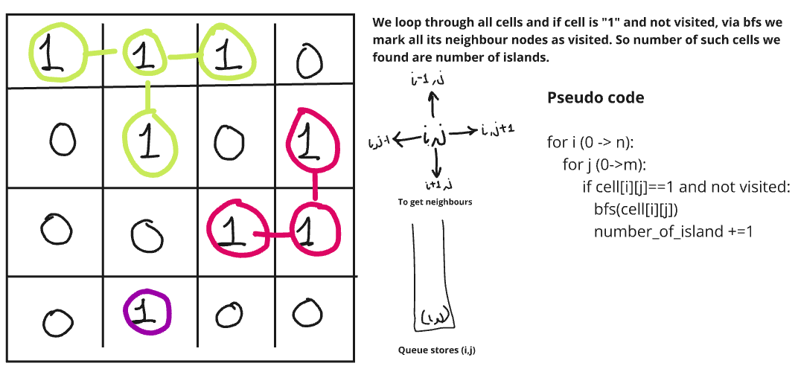

class Solution:
def numIslands(self, grid: List[List[str]]) -> int:

def dfs(i,j):
grid[i][j]=0
for d in range(4):
dx,dy = i+delta[d][0] , j+delta[d][1]
inRange = dx>=0 and dx<n and dy>=0 and dy<m
if inRange and grid[dx][dy] == "1":
dfs(dx,dy)

delta = [[0,1],[0,-1],[1,0],[-1,0]]
count = 0
n,m = len(grid), len(grid[0])
for i in range(n):
for j in range(m):
if grid[i][j]=="1":
count+=1
dfs(i,j)
return count

- Max Area of Islands
Method 1: Since Python does not have pass by reference concept, we can wither use global value or self.value which persist between recursion.

class Solution:
def maxAreaOfIsland(self, grid: list[list[int]]) -> int:

def dfs(i,j):
grid[i][j]=0
for d in range(4):
dx,dy = i+delta[d][0], j+delta[d][1]
inRange = dx>=0 and dx<n and dy>=0 and dy<m
if inRange and grid[dx][dy]==1:
self.area+=1
dfs(dx,dy)

#Each dfs will return the area covered in that iteration
n,m = len(grid), len(grid[0])
delta = [[1,0],[-1,0],[0,1],[0,-1]]
maxArea = 0
for i in range(n):
for j in range(m):
if grid[i][j]==1:
self.area=1
dfs(i,j)
maxArea = max(maxArea, self.area)
return maxArea

Here used different method to run dfs, without using visited array and using inner function, so that we won’t be required to pass multiple arguments.
class Solution:
def maxAreaOfIsland(self, grid: List[List[int]]) -> int:
m = len(grid)
n = len(grid[0])

#use of inner function
#returns number of times dfs was run
def dfs(i, j): # will return area
if i<0 or i>=m or j<0 or j>=n or grid[i][j]!=1:
return 0
else:
grid[i][j] = 0
return 1+dfs(i+1, j)+dfs(i, j-1)+dfs(i-1, j)+dfs(i, j+1)

#iterate all cells and run dfs if grid[i][j]==1
#inplace of using visited, can make grid[i][j]=0
max_area = 0
for i in range(m):
for j in range(n):
if grid[i][j] == 1:
max_area = max(max_area, dfs(i, j))

return max_area

- Number of enclaves
Approach: we just need count of all nodes which are covered from water in all sides. So we will just remove all land which are connected to edges by running DFS for all cells in edges. Whatever land is left will be our answers.
Note: we need to get all lands left after doing that, so whatever are water or are visited by DFS on edge cell will be marked as 0. So just count all left over 1’s are our answer.

class Solution:
def numEnclaves(self, grid: list[list[int]]) -> int:
def dfs(i,j):
if i<0 or i>=n or j<0 or j>=m or grid[i][j]==0:
return
grid[i][j]=0
dfs(i+1,j)
dfs(i-1,j)
dfs(i,j+1)
dfs(i,j-1)

#run dfs from edges of grid
n,m = len(grid), len(grid[0])
for i in range(n):
if grid[i][0]==1: dfs(i,0)
if grid[i][m-1]==1: dfs(i,m-1)
for j in range(m):
if grid[0][j]==1: dfs(0,j)
if grid[n-1][j]==1: dfs(n-1,j)

#1's left over after dfs from edges is answer
count=0
for i in range(n):
for j in range(m):
if grid[i][j]==1:
count+=1
return count

- Rotten Oranges

from collections import deque
class Solution:
def orangesRotting(self, grid: list[list[int]]) -> int:
n,m = len(grid), len(grid[0])
q = deque()

#inserting rotten oranges in queue [i,j,time]
for i in range(n):
for j in range(m):
if grid[i][j]==2:
q.append([i,j,0])

maxTime=0
delta = [[1,0],[-1,0],[0,1],[0,-1]]
while q:
node = q.popleft()
i,j,time = node[0],node[1],node[2]
maxTime = max(maxTime,time)
for d in range(4):
dx,dy = i+delta[d][0], j+delta[d][1]
if dx>=0 and dx<n and dy>=0 and dy<m and grid[dx][dy]==1:
grid[dx][dy]=2 #put here, once in queue, make it rotten
q.append([dx,dy,time+1])

for i in range(n): #if any orange is still not rotten, return -1
for j in range(m):
if grid[i][j]==1:
return -1

return maxTime

Solutions: Cycle Detection

2. Detect cycle in directed graph

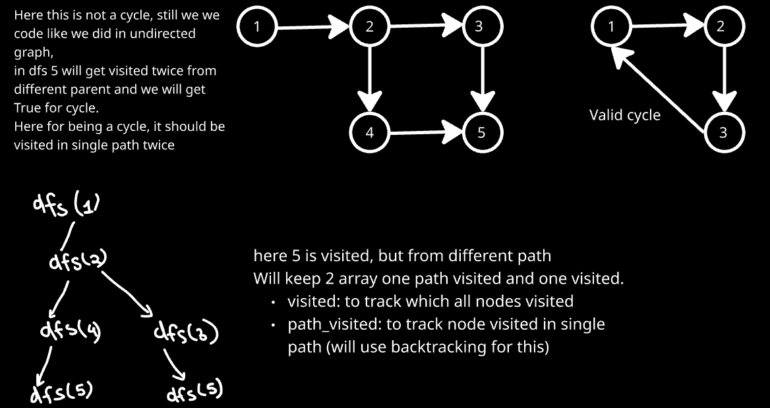

class Solution:

#helper code
def dfs(self,node, adj, visited, path_visited):
visited[node]=1
path_visited[node]=1

for neighbour in adj[node]:
if visited[neighbour]==1 and path_visited[neighbour]==1:
return True
elif visited[neighbour]==0:
if self.dfs(neighbour,adj,visited,path_visited):
return True

path_visited[node]=0
return False

def isCycle(self, V, edges):

adj= [[] for _ in range(V)]
for edge in edges:
adj[edge[0]].append(edge[1])

visited = [0]*V
path_visited = [0]*V

for i in range(V):
if visited[i]==0:
if self.dfs(i,adj,visited,path_visited):
return True

return False

- Bipartite Graph

#using BFS
from collections import deque
class Solution:
def isBipartite(self, graph: List[List[int]]) -> bool:
n=len(graph)
color = {}
#there can be many disconnected components of graph, therefore running loops to cover all
for i in range(n):
if i not in color:
color[i]=0
queue = deque([i])
while queue:
node = queue.popleft()

for neighbour in graph[node]:
if neighbour not in color:
color[neighbour] = 1-color[node]
queue.append(neighbour)
else:
if color[neighbour]==color[node]:
return False
return True

#Using DFS
class Solution:
def isBipartite(self, graph: List[List[int]]) -> bool:

def dfs(node):
for neighbour in graph[node]:
pc = color[node] #color of parent node
if color[neighbour]==-1:
color[neighbour] = 1-pc
if not dfs(neighbour): #if any of dfs return false, final ans is false
return False
elif color[neighbour]!=-1 and color[neighbour]==pc:
return False
return True

n = len(graph)
color=[-1]*n #will color 0 & 1 , -1 means not colored
#since graph are disconnected
for i in range(n):
if color[i]==-1:
color[i]=0 #start with parent node as 0 color
if not dfs(i): #if any dfs give false, graph is not bipartite
return False
return True

Solutions: Topological Sort

- Topological Sort

class Solution:

def topoSort(self, V, edges):
# Code here
adj =[[] for _ in range(V)]

for edge in edges:
adj[edge[0]].append(edge[1])

visited=set()
ans =[]

def dfs(node):
visited.add(node)
for neighbour in adj[node]:
if neighbour not in visited:
dfs(neighbour)
ans.append(node)

for i in range(V):
if i not in visited:
dfs(i)

return ans[::-1]

- Course Schedule

Note:
If length of topological sort = V(number of vertices), then it is valid topological sort. If this condition does not satisfy, then their must be a cycle, which was causing the issue.
So to detect cycle in directed graph, we can use topological sort.
But it works only for BFS(Kahn’s algorithm). As in that case only for some node indegree won’t become 0 ever and len(ans) will be less than number of vertices.
class Solution:
def canFinish(self, numCourses: int, prerequisites: List[List[int]]) -> bool:
adj = defaultdict(list)
indegree = [0] * numCourses

# Build adjacency list and in-degree count, have src connected to dest, as in [a,b] b needs to be finished before a, so edge from b to a
for dest, src in prerequisites:
adj[src].append(dest)
indegree[dest] += 1

# Queue for nodes with 0 in-degree (no prerequisites)
queue = deque([i for i in range(numCourses) if indegree[i] == 0])
ans=[]

while queue:
course = queue.popleft()
ans.append(course)
for neighbor in adj[course]:
indegree[neighbor] -= 1
if indegree[neighbor] == 0:
queue.append(neighbor)

return len(ans) == numCourses

- Loud and Rich

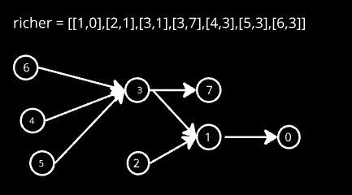
Approach: we will traverse from richer person and lower ones and propagate answers present in them to lower ones. Eg in above case, and from 6 is transferred to 3 which in turn propagates to 7 and 1 and then 0.
So will use Kahn’s algorithm to do so.

class Solution:
def loudAndRich(self, richer: List[List[int]], quiet: List[int]) -> List[int]:
n = len(quiet)
adj = [[] for _ in range(n)]
indegree=[0]*n
ans = [i for i in range(n)]
q=deque()

for edge in richer:
adj[edge[0]].append(edge[1])
indegree[edge[1]]+=1

for i in range(n):
if indegree[i]==0:
q.append(i)

while q:
node = q.popleft()

for neighbour in adj[node]:
if quiet[ans[node]] < quiet[ans[neighbour]]: #propogate ans to child
ans[neighbour] = ans[node]

indegree[neighbour]-=1
if indegree[neighbour]==0:
q.append(neighbour)

return ans

Solutions: Shortest Path

- Dijkstra Algorithm

import heapq
class Solution:
# Returns shortest distances from src to all other vertices
def dijkstra(self, V, edges, src):

adj = [[] for _ in range(V)]
for edge in edges:
adj[edge[0]].append((edge[1],edge[2]))
adj[edge[1]].append((edge[0],edge[2]))

distances = [float('inf') for i in range(V)]
distances[src] = 0

priority_queue = [(0,src)]

while priority_queue:
curr_dist, curr_node = heapq.heappop(priority_queue)

#skip if we already found better path
if curr_dist > distances[curr_node]:
continue

for neighbor in adj[curr_node]:
n_node, n_wgt = neighbor[0], neighbor[1]
n_dist = curr_dist + n_wgt

if n_dist < distances[n_node]:
distances[n_node] = n_dist
heapq.heappush(priority_queue, (n_dist, n_node))

return distances

- Shortest Path in Weighted Undirected Graph

import heapq
from typing import List

class Solution:
def shortestPath(self,n:int, m:int, edges:List[List[int]] )->List[int]:
# vertices 1 to n, find path from 1 to n ( 1-based indexing )
adj = [[] for _ in range(n+1)]
for edge in edges:
adj[edge[0]].append((edge[1], edge[2]))
adj[edge[1]].append((edge[0], edge[2]))

pq = [(0,1)]
parent = [i for i in range(n+1)]
dist = [float('inf')]*(n+1)
dist[1] = 0 #src

while pq:
curr_dist, curr_node = heapq.heappop(pq)

if curr_dist > dist[curr_node]:
continue

for neighbor in adj[curr_node]:
n_node, n_wgt = neighbor[0], neighbor[1]
n_dist = curr_dist + n_wgt

if n_dist < dist[n_node]:
dist[n_node] = n_dist
parent[n_node] = curr_node
heapq.heappush(pq, (n_dist, n_node))

#if node n was not visited
if dist[n] == float('inf'):
return [-1]

path = []
node = n
while parent[node] != node:
path.append(node)
node = parent[node]
path.append(1)

return [dist[n]] + path[::-1]

- Shortest Distance in a Binary Matrix

import heapq
from typing import List

class Solution:

def shortestPath(self, grid: List[List[int]], source: List[int], destination: List[int]) -> int:
n, m = len(grid), len(grid[0])
dist = [[float('inf')]*m for _ in range(n)]

pq = [(0, source)]
dr, dc = [0,1,0,-1], [1,0,-1,0]
dist[source[0]][source[1]] = 0
if source == destination:
return 0

while pq:
wgt , node = heapq.heappop(pq)
x,y = node[0], node[1]

if wgt > dist[x][y]:
continue

for d in range(4):
nx, ny = x + dr[d] , y + dc[d]
if nx>=0 and nx<n and ny>=0 and ny<m and grid[nx][ny]==1:
n_dist = wgt+1
n_node = [nx, ny]

if n_node == destination:
return n_dist
if n_dist < dist[nx][ny]:
dist[nx][ny] = n_dist
heapq.heappush(pq, (n_dist, n_node))

return -1

- Path With Minimum Effort
Intuition:
We want a path where the largest height jump is as small as possible, not the shortest distance.
So we always expand the cell with the minimum current maximum jump using a min-heap (Dijkstra).
The first time we reach the destination, that effort is guaranteed to be minimum.

Approach
- Treat each cell as a graph node and each move as an edge with cost = height difference.
- Use Dijkstra’s algorithm with a min-heap to always process the path with the smallest effort first.
- Store the minimum effort needed to reach every cell in a dist matrix.
- For each move, update effort as max(current_effort, height_difference).
- When destination cell is popped from heap, return its effort (minimum possible).

class Solution:
def minimumEffortPath(self, heights: List[List[int]]) -> int:
n, m=len(heights), len(heights[0])
q=[]
heapq.heappush(q,(0,0,0))
dist=[[float('inf')]*m for i in range(n)]
dist[0][0]=0

while q:
effort,x,y=heapq.heappop(q)
if x==n-1 and y==m-1:
return effort
for dx,dy in [(0,-1),(0,1),(-1,0),(1,0)]:
X=x+dx
Y=y+dy
if 0<=X<n and 0<=Y<m :
new=max(effort,abs(heights[x][y]-heights[X][Y]))
if dist[X][Y]>new:
dist[X][Y]=new
heapq.heappush(q,(new,X,Y))
return -1

- Cheapest flights within k stops

Why Priority Queue Stores Stops?
Heap stores: (stops, current_city, total_cost)
Because:
- Two paths may reach the same city with different stops.
- A path with lower cost but more stops might be invalid.
- A path with slightly higher cost but fewer stops might be valid.
- We must know how many stops were used when reaching a city.
Stops act as a constraint filter.

Approach
- Build adjacency list from flights.
- Use a min heap (priority queue) to explore paths.
- Each heap entry contains: (stops_used, current_node, total_cost)
- Start from src with: (0 stops, src, 0 cost)
- Pop cheapest path from heap:
  - If stops exceed k → skip
  - Try all neighbors: If new cost is smaller → push into heap with stops+1
- Keep updating minimum cost to each node.
- If destination is unreachable → return -1.

class Solution:
def findCheapestPrice(self, n: int, flights: List[List[int]], src: int, dst: int, k: int) -> int:
adj=[[] for _ in range(n)]
for u,v,w in flights:
adj[u].append((v,w))

dist=[float('inf')]*n
dist[src]=0
q=[]
heapq.heappush(q,(0, src, 0))

while q:
stops,node,wgt=heapq.heappop(q)
if stops>k:
continue
for neighbor,w in adj[node]:
if dist[neighbor]>wgt+w and stops<=k:
dist[neighbor]=wgt + w
heapq.heappush(q,((stops+1,neighbor,wgt+w)))

if dist[dst]==float('inf'):
return -1

return dist[dst]
- Distance from the Source
Basic implementation of Bellman Ford Algorithm

class Solution:
def bellmanFord(self, V, edges, src):
dist = [float('inf')] * V
dist[src] = 0

for _ in range(V-1):
for u,v,wgt in edges:
if dist[u] != float('inf') and dist[u] + wgt < dist[v]:
dist[v] = dist[u] + wgt

#check for negative cycle
for u,v,wgt in edges:
if dist[u]!=float('inf') and dist[u] + wgt < dist[v]:
return [-1]

for i in range(V):
if dist[i]==float('inf'):
dist[i] = 10**8

return dist

- Find City With Smallest Number of neighbors at threshold distance
class Solution:
def findTheCity(self, n: int, edges: List[List[int]], distanceThreshold: int) -> int:
cost = [[float('inf')] * n for _ in range(n)]
for i in range(n):
cost[i][i] = 0
#for undirected, convert to 2 directed path
for u, v, w in edges:
cost[u][v] = w
cost[v][u] = w

# **Floyd-Warshall**
for i in range(n):
for j in range(n):
for k in range(n):
if cost[j][k] > cost[j][i] + cost[i][k]:
cost[j][k] = cost[j][i] + cost[i][k]

city = -1
min_reachable = n + 1

for i in range(n):
cnt = sum(1 for d in cost[i] if d <= distanceThreshold)
if cnt <= min_reachable:
min_reachable = cnt
city = i

return city

- Word Ladder

Key Insight: This is a shortest path problem in an unweighted graph where:
- Each word is a node
- Two words are connected if they differ by exactly one letter
- We need the shortest path from beginWord to endWord

Why BFS?
- BFS explores level-by-level (transformation by transformation)
- First time we reach endWord = shortest sequence
- Each transformation = 1 edge = unit distance

Dry Run
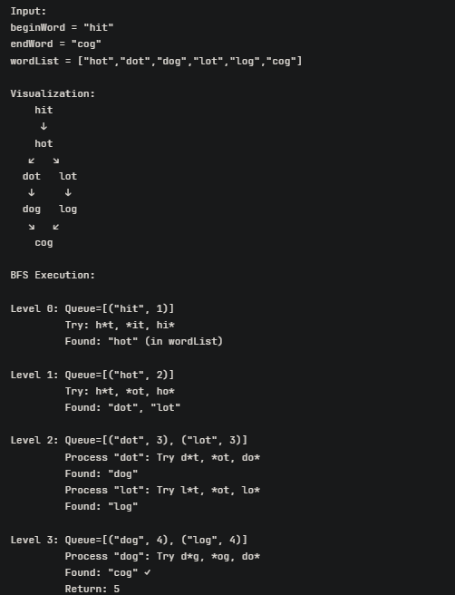

class Solution:
def ladderLength(self, beginWord: str, endWord: str, wordList: List[str]) -> int:
wordset = set(wordList)

#if end word not it list, it is impossible
if endWord not in wordset:
return 0

#BFS : queue stores [word,level]
q = deque()
q.append([beginWord,1])
visited = set([beginWord])

while q:
node, length = q.popleft()
if node == endWord:
return length
# Try changing each character position
for i in range(len(node)):
for c in 'abcdefghijklmnopqrstuvwxyz':# Try all 26 letters
next_word = node[:i] + c + node[i+1:]

if next_word in wordset and next_word not in visited:
q.append([next_word, length+1])
visited.add(next_word)

return 0

